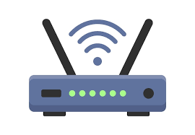

Information Systems Capstone Documentation

Wireless Private Network

Casey Gunter

3/31/2025-6/6/2025

Table of Contents

Raspberry Pi 5 Components and Changes 2

PBX System Using 3CXOne 2

VPN Server Using OPNSense 2

Firewall Using Palo Alto 2

Softphones 2

Armbian 3

AWS Buckets 3

AWS EC2 Instances 3

AWS IP Tables 3

Executables 3

# Raspberry Pi 5 Components and Changes

# PBX System Using 3CXOne

# VPN Server Using OPNSense

# Firewall Using Palo Alto

# Softphones

# Armbian

# AWS Buckets

# AWS EC2 Instances

# AWS IP Tables

# Executables